**How to use the Rosemann API**

1. **Go to Excel Online. (outlook.com) and create a new Excel document.**

**Insert Machine Learning API as follows:**

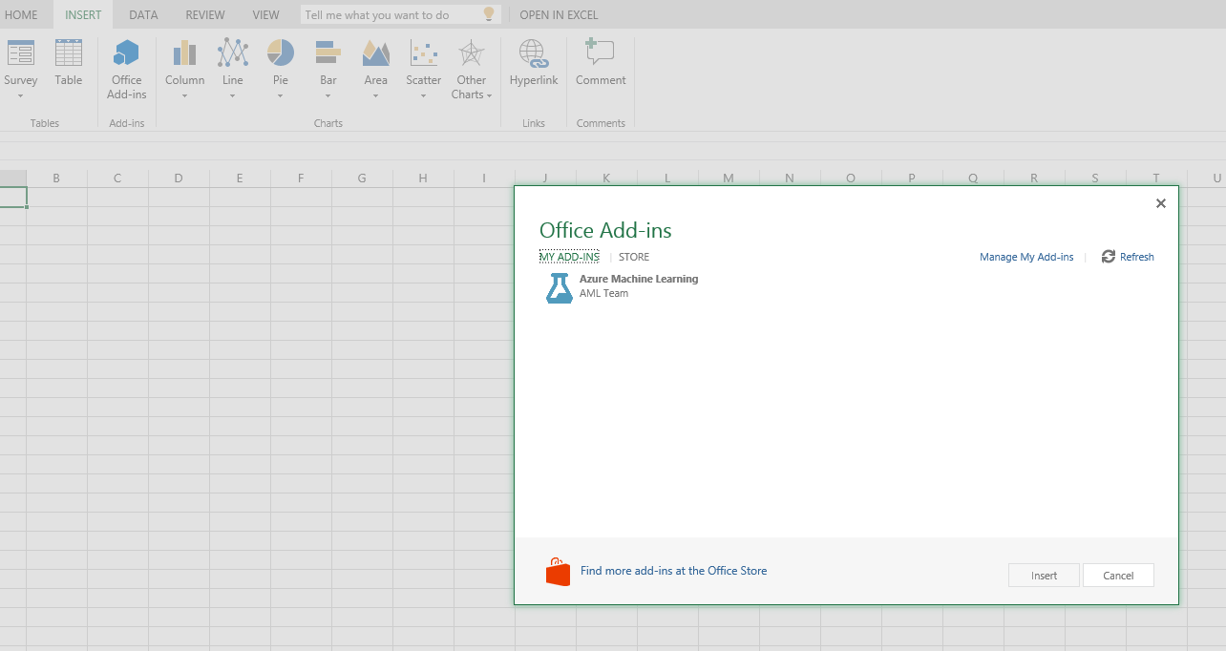

1. **Type in the WEB SERVICE URL and ACCESS KEY given in the file Rosemann Sales Prediction APL.xlsm, to insert the API.**

**( WEB SERVICE URL:**

[**https://studio.azureml.net/apihelp/workspaces/bd165a4ada1c4a5894518128e8043f52/webservices/d1b75a9ea5094c40a57b62ecc70fc6d8/endpoints/2dbe085da43445bea8aa0c751262f1ad/score**](https://studio.azureml.net/apihelp/workspaces/bd165a4ada1c4a5894518128e8043f52/webservices/d1b75a9ea5094c40a57b62ecc70fc6d8/endpoints/2dbe085da43445bea8aa0c751262f1ad/score)

**ACCESS KEY:**

tPpaC6bHiXvu7af3M0dxXONwd3vrvZgP8gI5ASSaW1dzDapxQr2jwZ04Uty2hy1Gqtni43zSHV26Sl8r03oILQ==

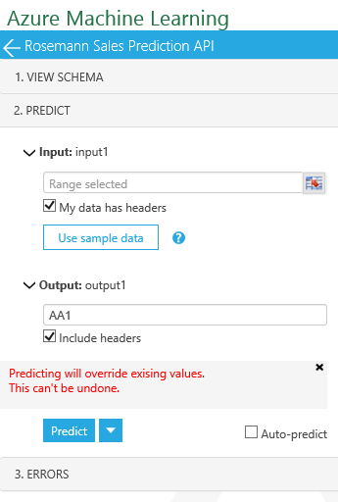

1. **Click the “Use Sample data”, then the table comes up.** 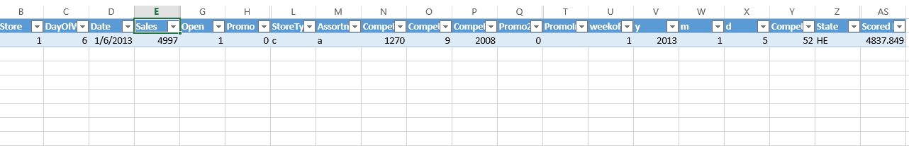

**Type in some values, you can utilize the ML model to do predictions!**